22 September 2024 postcard

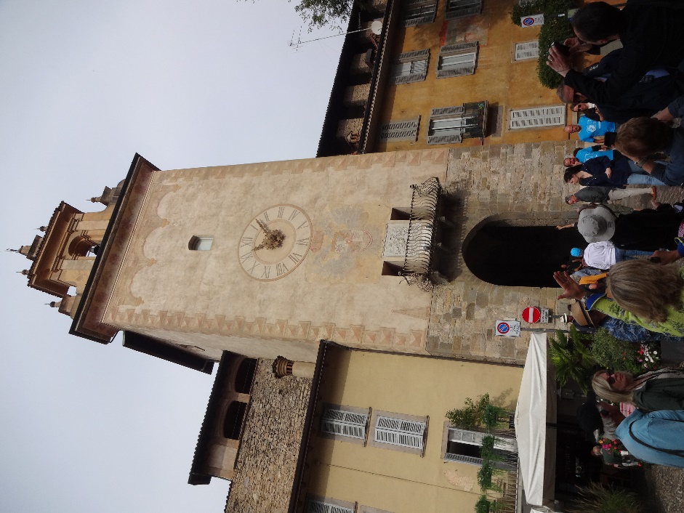We were scheduled to leave Stresa at 8 am this morning, so our tour director arranged for the hotel to open breakfast at 7 am rather than 7:30 am, to give us sufficient time. But the bus driver said that, because it was Sunday, traffic would be light and we could leave at 8:20 am. Just as well, since the hotel staff weren't really ready for us at 7 am.

By the time we finished breakfast, our luggage had been collected and loaded onto the bus, so off we went to Bergamo. I had no idea what Bergamo was known for, but it turns out to be just a really nice little historic town. Here's the "small bell tower," our rendez-vous point for our return to the buses later.

This is he "large bell tower" further along in our walking tour.

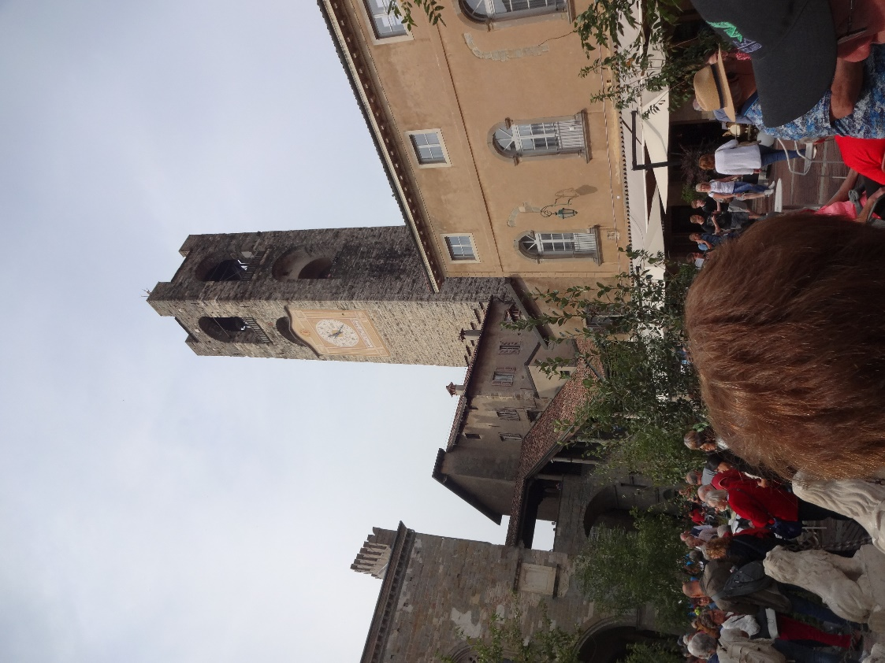

The place was a little crowded because we were there on the day of an annual fun run/walk around the perimeter of the old medieval walls, but our local guide took us many places well away from the crowds, especially the crypt of the basilica, where three layers of Roman ruins had been unearthed.

After our tour of Bergamo—a particularly detailed, interesting, and informative one—we headed back to the buses for the trip to a winery in the Franciacorta region called Al Rocol. In addition to making wine and olive oil, the family who have owned and run it for four generations also practice "agritourism"—they run a restaurant that feature local products, including their own wine and oil, as well as renting out a few rooms to those curious about the working of the farm.

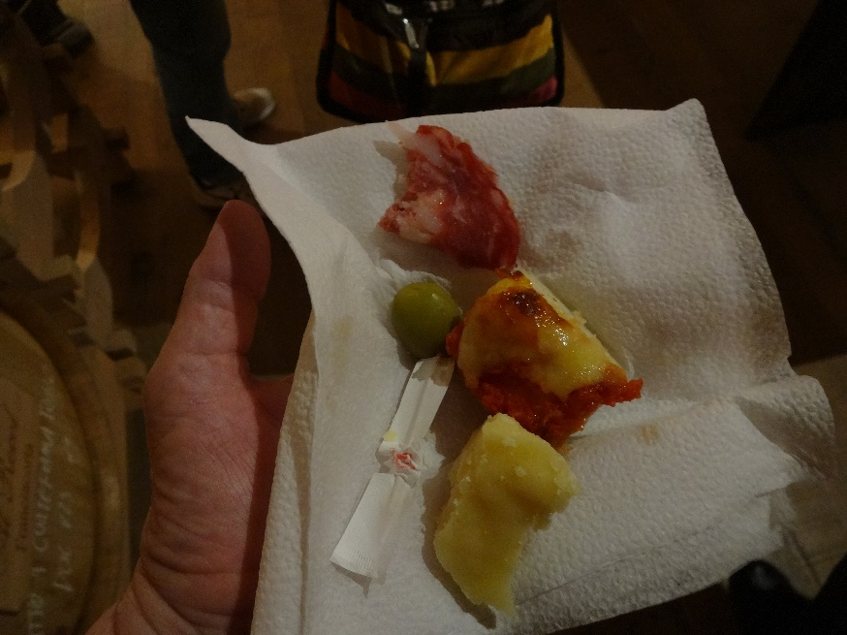

To complement their "champagne" (identical in all details of production to real champagne, but forbidden to bear the name, which is a registered trademark of the region of France by that name), they served us hors d'oeuvres: slices of a delicious soft salami, their own olives on paper-wrapped toothpicks, little squares of pizza, and chunks of "grana Padano," a Parmesan-like cheese that again isn't produced close enough to Parma to use the name.

We had an excellent introduction to the process of producing sparkling wine by the champagne method before moving to their restaurant pavilion for a three-course lunch consisting of assorted starters, a plate of excellent pasta with cherry tomatoes and olives, and vanilla ice cream with strawberry sauce.

Then back into the bus again for the trip to our hotel in Verona, where we'll be for the next two nights. Our big bus couldn't get anywhere near it through the tiny Renaissance-era streets, so we were met on the outskirts of the old town by a small fleet of limo vans which ferried us there.

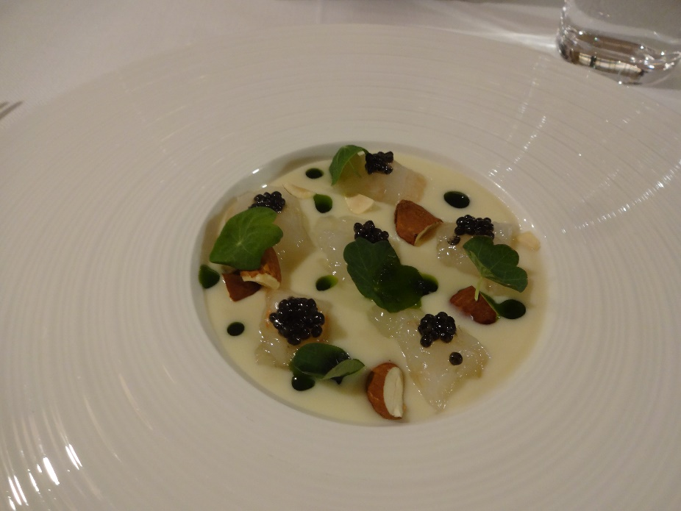By that time it was 6 pm, so again David and I just stayed in the hotel and had a lovely supper at their "Bistro." I started with raw langoustines with caviar and almonds in a champagne sauce, garnished with nasturtium leaves.

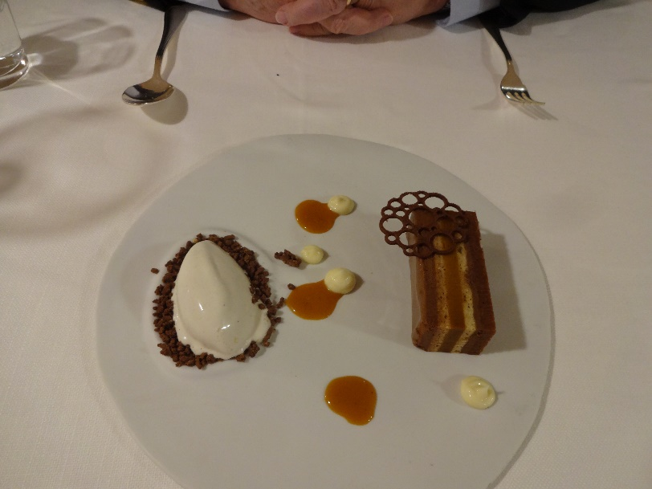For dessert, we split their dessert of chocolate, caramel, and vanilla ice milk.